Faith Without Works is Dead
September 3, 2016
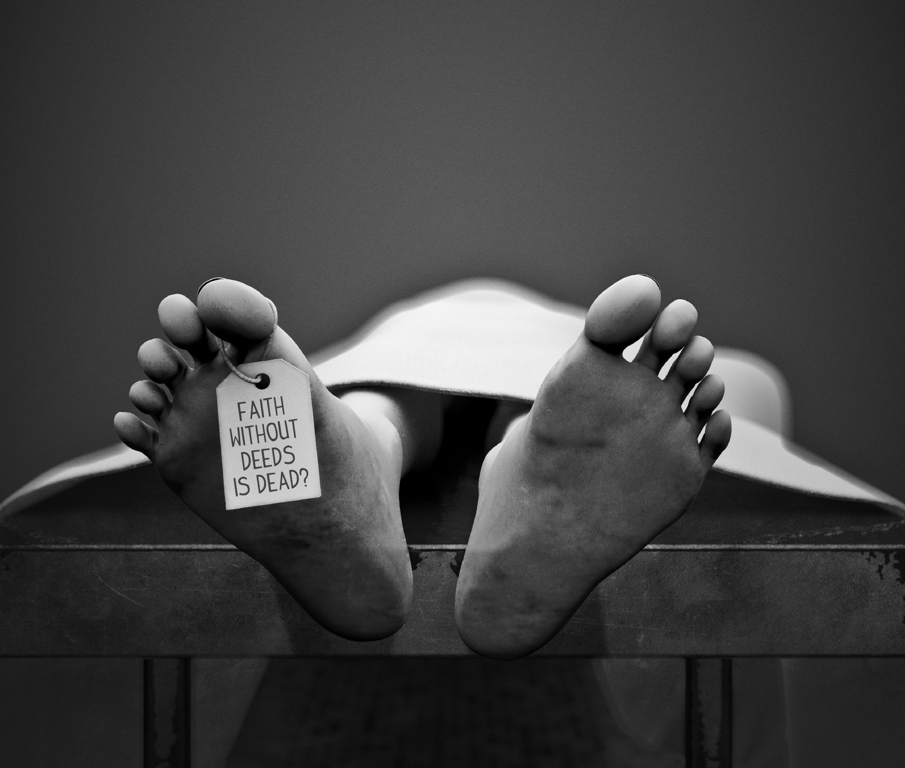
May the Lord’s peace be with you, and may our hearts be open to His instruction to keep our peace.

Just a quick announcement. I wanted to let you know that Love Letters To My Bride volume 3 is now for sale on Amazon. I have already used it for rhemas and I love the messages the editor, Mike Peralta, put together, they truly are choice.

Tonight, the Lord wanted me to be quiet with Him and we listened to the crickets together. I love this time of the year when the crickets make their lovely sounds at night.

He began, "Speaking about world events. Things are going to get turbulent, Clare. But I want My people to remain calm. Steady as she goes.

"I have given assignments and some have done wonderfully. For instance, Leah and the Water of Life music.”

That's a site that I had checked out today. Leah had written me an email. I went to go and listen to her site. She's been really, really in love and on fire for the Lord. And she's written some beautiful music with Him, wonderful songs. Songs that really minister. And her name is Leah Catherine at WaterofLifemusic.com - her website.

The Lord continued, "She has moved forward with Me in obedience to My mandate to use her gifts. Heartdwellers, she is a good example for you.

"Some of you who have been expecting the Rapture have not been using your gifts, because you have presumed there wasn’t time. I am asking you, My people, please do not let Me down. Get busy, there is time - you have been deceived.

"Many have said, 'Well, since the Rapture isn’t for three years, I can just take it easy.' You who are thickening on your lees - you will not be taken."

I looked up that word, LEES: “A word in the KJV that describes that undisturbed and thick portion of wine that naturally falls to the bottom of the vat. The dregs that settled at the bottom of wine jars and wineskins. The word is used to express spiritual lethargy and the decadence of Moab (Jer. 48:11), the indifference of Israelites to spiritual realities (Zeph.1:12), and the bitterness and inevitability of God’s wrath on the wicked (Ps.75:8). Zephaniah 1:12 records that they are “thickening upon their lees” who say that Jehovah will do nothing. Jeremiah 48:11 says that Moab has “settled on his lees”; that is, they have settled down in contentment with their circumstances."

"Though I love you with all My heart, I am giving you a serious warning; please hearken to My call. I need you to use your gifts while you are waiting. I need your focus to be bringing others to salvation, not how soon the Rapture will happen and soon you can get off this Earth. Shall I reward you with the same reward given to those who are laboring to bring in the harvest - knowing that they have yet a little time to bring forth fruit? I have no desire to leave you behind, but that is what is going to happen with the servants that buried their talents. Please do not be one of them.

"Moving on to world events. Birth pains are continuing in the world. They are closer together now, because they are coming to a climax. But I will continue to leave venues up to reach souls around the world. In fact, the Internet is going to flourish with spiritual vigor and life. Take advantage of this time to spread the Gospel.

"You see, your faith is holding the world together. You who have given your lives to Me to spread the Gospel know that I am a faithful God and I would not commission you to work if all the doors were going to close. This is what the enemy wants. But for now, it is not possible and will not succeed. This is something they have wanted to do for a long time, but put it off. Now it’s too late, because the world has woken up.

"There will be numerous attempts to throw everything into chaos, here and abroad. I will thwart them all for those souls who are riveted on Me and not looking to the left or right.

"Some of you are new to this channel. I have made it a point to tell everyone that I do not want them watching the news and Youtubes that keep abreast of the chaos. Why? Because you, by your negative thinking, will spread negativity and instability. Do you all understand? Even the ‘good’ Christian channels that broadcast what’s happening are working against the stability of the world. Unknown to them, some of the information they have is deliberately slanted to throw people into a panic. But those of you who are expecting Me to keep you in peace are in fact part of what is holding this world together. That is why you must be removed before all the plans they have can be implemented.

"Your nervousness about the times has for its motive: fear. That is what is being broadcast, because fearful people are easier to control. I have told you when the season for the Rapture will be ripe. So you can relax and reject that fear, staying busy for Me and resting in Me.

"Many of you do not know what it means to enter into My rest. It means leaving off with your own devices, motivated by fear. Should a Tsunami come, I will take you Home and you will be first to be raptured. Should an earthquake come, still I will take care of you. If you release all your anxiety about your bodies and the salvation of your relatives, and just focus on steady application of your gifts to bring souls to Me, you will have PEACE. My PEACE.”

"As it is written: The work of righteousness will be peace, And the service of righteousness, quietness and confidence forever. Isaiah 32:17

"You can never adequately cover for yourself. There will always be tension over the 'one more thing' you don’t have. The latest ‘prophecy’ of when the comet will strike, when the war will begin. Don’t you see that you are being worked up to a frenzy every time a new date is set? Dear ones, really! Don’t you see you are being manipulated? You are playing into the hands of the enemy. You can never adequately prepare, but I am always prepared to bring you to safety.

"The more insecure you get, the more you focus on yourselves, the less you do for the Kingdom. This is so very selfish. I have taught you that if you focus on Me alone and obey what’s been given to you to do, I will cover for you. You can walk in freedom. Now you are in bondage to all these dates being set. They have stolen your gifts by causing you fear and apprehension, even though I have consistently told you not to listen to the voice of the world.

"Please listen to My voice alone - wherever you hear it. In church, on other channels, in your prayer time - wherever you hear it, let it be settled in your mind and enter into My rest. Then, no matter what happens, you will have My peace and assurance that I will for cover you.

"This is a struggle against faith. You are being manipulated to forsake your faith and turn to your own devices. And this is precisely how they will drive you into the net that’s been prepared for you. 'Come to us, we have food, water, blankets, medicine…come.' And it will be a trap to incarcerate and eventually do away with you.

"You need to practice your faith and trust in Me...now. You need to be an example of My watchful care...now. You need to be spreading the gospel by living it NOW, so that those who are left behind will have an example to remember."

Lord, I don't understand - how this is stealing people's faith?

He continued, "Because you are getting worked up with fear, and the flesh rises up to overpower the spirit. Fear is a most powerful weapon. It is not only making your bodies sick, but your souls as well. You cannot hear My still small voice when your head is filled with the din of the world.

"As it is written: In repentance and rest you will be saved, In quietness and trust is your strength. But you were not willing, And you said, 'No, for we will flee on horses,' Therefore you shall flee! 'And we will ride on swift horses,' Therefore those who pursue you shall be swift.…Isaiah 30:16

He who said to them, "Here is rest, give rest to the weary," And, "Here is repose," but they would not listen. Isaiah 28:12

"Do not be among the unbelieving but believe. Let your faith shine through the works I have given you to do. While all the world is stressing, you will be creating. It’s in your hands, it’s your choice.

Then He quickened James to me “…faith by itself, if not complemented by action, is dead. But someone will say, “You have faith and I have deeds.” Show me your faith without deeds, and I will show you my faith by my deeds.…”
James 2:17

